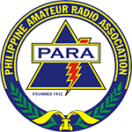
Theme: HAMRADIO-“Transmit your love, reducing the global burden of disaster”

2017 PARA NATIONAL HAMRADIO CONVENTION

Hosted by: Frequency for Amateur Radio Enthusiasts 8 Inc. ( FARE-8, INC))
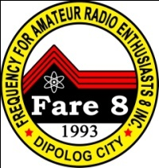
Dipolog City, Zamboanga del Norte, Philippines
Souvenir Program Advertisement Contract Form

Name : ________________________________________________ Callsign: _______________
Address: ________________________________________________________________________
Group: ________________________________________________________________________
Phone No.___________________(H)_______________________(W) _______________________
Email: __________________________________________________________________________

Please check only one of the blocks below:

I want to post a _______________ page advertisement in the 2017 PARA National Hamradio

Convention.

I just want to post a Patron Donor Name in the 2017 PARA National Hamradio Souvenir Program

Please post the following information:

Name : _____________________________________Callsign(if any)____________________

Signature: ___________________________________ Date: ___________________________

2017 PARA NATIONAL HAMRADIO CONVENTION Souvenir Program

- Full color, whole page ad | P 20,000.00
- Full color, whole page ad inside front/back cover | P 15,000.00
- Black & White, full page ad | P 3,000.00
- Black & White half page ad | P 1,500.00
- Black & White, quarter page ad | P 750.00
- Patron Donor (name only) | P 500.00

Notes:

- Advertiser for full and half page sizes will get a complementary copy of the souvenir program.
- Advertiser assumes all responsibilities for accuracy of information presented in the advertisement material, DX8FAR will not bear any responsibility or liability as a result of erroneous information as provided.
- Advertisement material shall be sent to DX8FAR before the deadline of March 10, 2016. Please send the filled up and signed original copy of this advertisement Contract Form and the “camera ready” artwork and photographs together with the proper amount Cash/Check.

c/o Marlou G. Atillo, DV8WX Account Name: Frequency for Amateur Radio Enthusiasts 8 Inc.
Biasong, Dipolog City Bank : BDO BANK
Cel# 09109787777 Branch : Quezon Avenue
09214219990 Account No. : 003130275473

